**FOOTBALL NOTES**

**I. POSITIONS**

**1.** **Offense**

C = center

G = guard

T = tackle

TE = tight end

WR = wide receiver

FB = flanker back

QB = quarterback

RB = running back

“PRO” FORMATION: (FB & TE on same side)

RB RB

**O** **O**

QB

**O** FB **O**

**O O O O O O O** WR

TE T G C G T

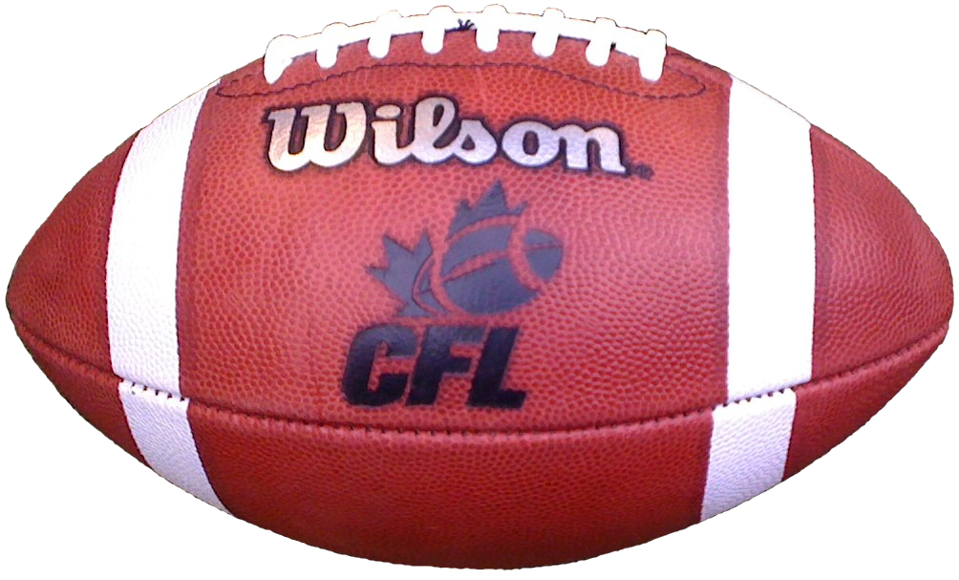

**“Pro Right, Split Backs”**

**Huddle:**



**2.** **Defense**

DT = defensive tackle

DE = defensive end

LB = linebacker

CB = cornerback

S = safety

**O** S **O** S

**O** CB **O** CB

**O** LB **O** LB **O** LB

**O** DE **O** DT **O** DT **O** DE



**“43 Defense”**

**Huddle:**



**II. RULES**

**1. Moving the ball down the field**

a) The ball can be moved by running with it or throwing it to another player (passing)

b) A team is allowed 4 plays (**downs**) to advance the ball forward 10 yards

c) If the offense is successful in moving at least 10 yards in 4 plays or less, 4 new plays are awarded (you may not add unused plays)

d) After the player with the ball is stopped (tackled), the ball is place at that spot to begin the next play (**line of scrimmage**)

e) If a player is thrown the ball and drops it, the ball is placed at the spot where the play started

**2. Kicking the ball**

a) kickoff - used to start a game and how new team receives the ball after a score

b) punt - used when offensive team does not think they can make it the necessary 10 yards and are on their fourth play

**3. Scoring**

a) Touchdown - 6 points

b) Extra point - 1 point (kick), 2 points (run or pass)

c) Field goal - 3 points

d) Safety - 2 points

**4. Penalties**

a) A penalty occurs when a player breaks a rule

b) A team is penalized in a loss of yards (5, 10, or 15) or plays

**III. Field**

